ABOUT LAST C

Code1.c- SWAP TWO NUMBERS USING CALL BY REFERENCE

Code2.c-

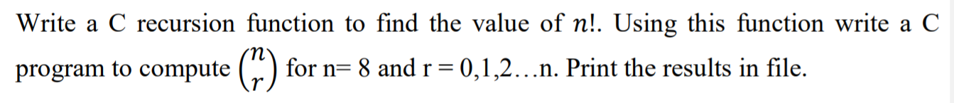

Code3.c-

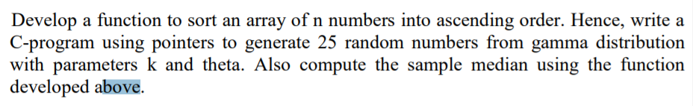

Code 4.c-

2D ARRAY’S AND POINTERS

(LOGIC SESSION)

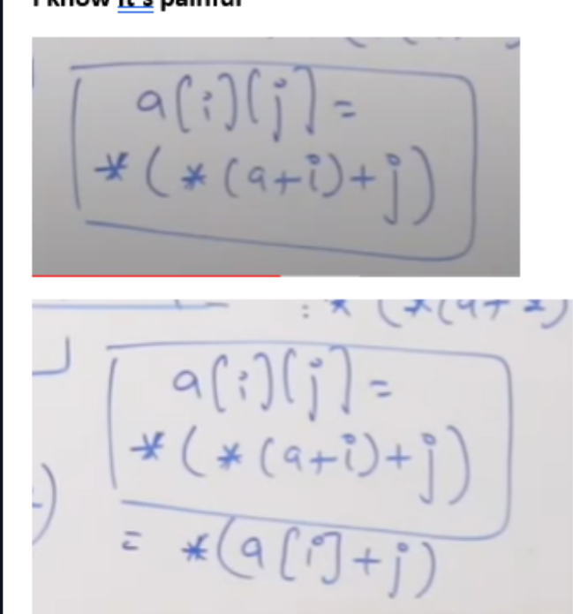

Code5c-

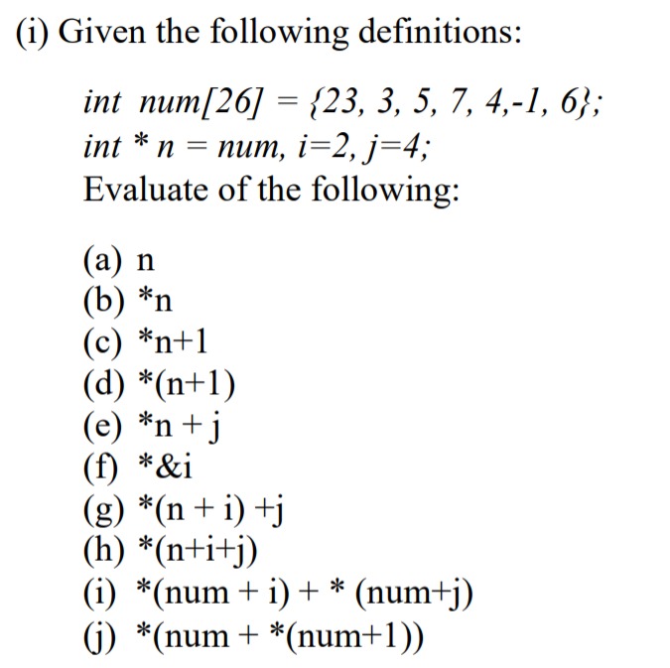

Code 6.c

